Name:

MTH133
Unit 2 Individual Project
Name:

1) Solve the following by factoring:

a) $x^{2}+7x+\text{10}=0$

Answer:
Show your work here:

b) $3x^{2}−6x=0$

Answer:
Show your work here:

2) If $f(x)=2x^{2}−7x+3$, find:

a) f(2)

Answer:
Show your work here:

b) f(-3)

Answer:
Show your work here:

3) Solve $2x^{2}−3x−2=0$ using the quadratic formula.

Answer:
Show your work here:

4) Use the graph of $y=−x^{2}+4x+5$ to answer the following:

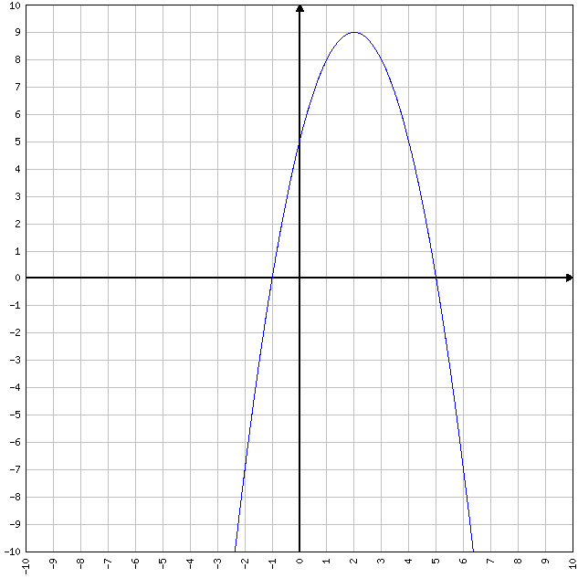
a) Using the graph, what are the solution(s) to the equation $−x^{2}+4x+5=0$?

Answer:
Explain how you obtain your answer(s) by looking at the graph:

b) Does this function have a maximum or a minimum?

Answer:
Explain how you obtain your answer by looking at the graph:

c) What are the coordinates of the vertex in (x, y) form?

Answer:

d) What is the equation of the line of symmetry for this graph?

Answer:

5) a) Calculate the value of the discriminant of $x^{2}+x+3=0$ .

Answer:
Show your work here:

b) By examining the sign of the discriminant in part a, how many x-intercepts would the graph of $y=x^{2}+x+3$have? Why?

Answer:

6) a) Find the corresponding y values for x= -2, -1, 0, 1, 2, 3 if$y=x^{2}−x−2$.

Answer (fill in y column)
x | y
-2
-1
0
1
2
3

Show your work here: (type x-squared as x^2 unless using a superscript feature).

b) Use Microsoft Excel or another web-based graphing utility to plot the points found in part a and to sketch the graph. Read the information in the assignments list to learn more about how to graph in MS Excel.

7) The path of a falling object is given by the function $s=−\text{16}t^{2}+v_{0}t+s_{0}$ where $v_{0}$represents the initial velocity in ft/sec and $s_{0}$represents the initial height in feet.

a) If a rock is thrown upward with an initial velocity of 64 feet per second from the top of a 25-foot building, write the height (s) equation using this information.

Typing hint: Type t-squared as t^2
Answer:

b) How high is the rock after 1 second?
Answer:
Show your work here:

c) After how many seconds will the graph reach maximum height?
Answer:
Show your work here:

d) What is the maximum height?
Answer:
Show your work here:

